**Question 01:**

**CODE**

#include<stdio.h>

#include<string.h>

struct data{

char roll_number[7];

char name[20];

char dept[10];

char course[20];

int year_join;

};

void main(void){

struct data students_data[450];

int size=0;

printf("Please enter the size:\n");

scanf("%d",&size);

int i;

for(i=0; i<size; i++){

fflush(stdin);

printf("Enter the ROLL NUMBER:\n");

gets(students_data[i].roll_number);

printf("Enter the name:\n");

gets(students_data[i].name);

printf("Enter the name of department:\n");

gets(students_data[i].dept);

printf("Enter the name of course:\n");

gets(students_data[i].course);

printf("Enter the year of joining\n");

scanf("%d",&students_data[i].year_join);

}

/*for(i=0; i<size; i++){

puts(students_data[i].roll_number);

puts(students_data[i].name);

puts(students_data[i].dept);

puts(students_data[i].course);

printf("%d",students_data[i].year_join);

}*/

char search[7];

printf("Enter the roll number to search for the candiddate:\n");

fflush(stdin);

gets(search);

int val;

for(i=0; i<size; i++){

val=strcmp(students_data[i].roll_number,search);

if(val==0){

puts(students_data[i].roll_number);

puts(students_data[i].name);

puts(students_data[i].dept);

puts(students_data[i].course);

printf("%d",students_data[i].year_join);

}

}

int year;

printf("\nEnter the year to search:\n");

scanf("%d",&year);

for(i=0; i<size; i++){

if(students_data[i].year_join==year){

puts(students_data[i].roll_number);

puts(students_data[i].name);

puts(students_data[i].dept);

puts(students_data[i].course);

printf("\n%d\n\n",students_data[i].year_join);

}

}

}

**OUTPUT**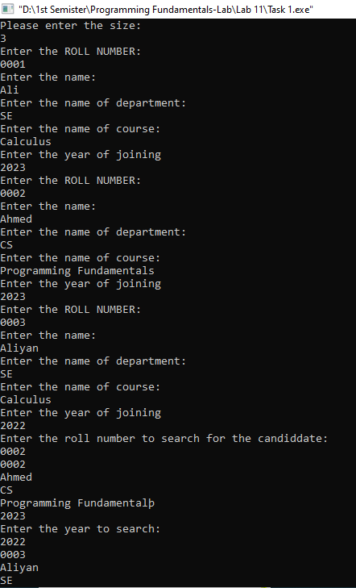

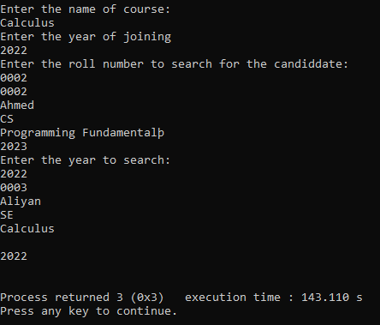

**QUESTION 02:**

**CODE**

#include<stdio.h>

#include<string.h>

struct engine_parts{

int serial;

int year;

char material[20];

int quantity;

};

void main(void){

int size=0;

printf("Enter the size you want:\n");

scanf("%d",&size);

struct engine_parts var[size];

int i;

for (i=0; i<size; i++){

printf("Enter the serial number:\n");

scanf("%d",&var[i].serial);

printf("Enter the year:\n");

scanf("%d",&var[i].year);

printf("Enter the material nature:\n");

fflush(stdin);

gets(var[i].material);

printf("Enter the quantity:\n");

scanf("%d",&var[i].quantity);

}

int search_serial=0;

printf("Enter the serial from which you want to search:\n");

scanf("%d",&search_serial);

int count=0;

printf("Enter the number of serial you want from the serial you entered:\n");

scanf("%d",&count);

int j=0;

for(i=0; i<size; i++){

if(search_serial==var[i].serial){

for(j=0; j<count; j++){

printf("%d\n",var[j+i].serial);

printf("%d\n",var[j+i].year);

puts(var[j+i].material);

printf("%d\n",var[j+i].quantity);

}

break;

}

}

}

**OUTPUT**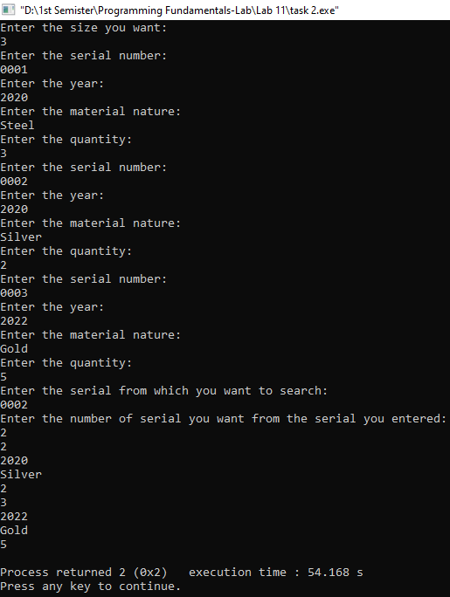

**QUESTION 03:**

**CODE**

#include<stdio.h>

#include<string.h>

struct date{

int dd;

int mm;

int yy;

};

void main(void){

struct date inputs[2];

int i;

for(i=0; i<2; i++){

printf("Enter the %d date in dd-mm-yy:\n",i+1);

scanf("%d%d%d",&inputs[i].dd,&inputs[i].mm,&inputs[i].yy);

}

for(i=0; i<2; i++){

printf("%d %d %d\n",inputs[i].dd,inputs[i].mm,inputs[i].yy);

}

for(i=0; i<1; i++){

if(inputs[i].dd==inputs[i+1].dd){

if(inputs[i].mm==inputs[i+1].mm){

if(inputs[i].yy==inputs[i+1].yy){

printf("The dates are equal\n");

}

}

}

else{

printf("The dates are not equal\n");

}

}

}

**OUTPUT**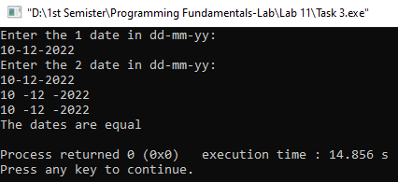

**QUESTION 04:**

**CODE**

#include<stdio.h>

#include<string.h>

struct date{

char name[20];

int salary;

int work_hour;

};

void main(void){

struct date var[10];

int i;

for(i=0; i<10; i++){

printf("\n%d",i+1);

printf("\nEnter the name:\n");

fflush(stdin);

gets(var[i].name);

printf("Enter the salary:\n");

scanf("%d",&var[i].salary);

printf("Enter the hours of work:\n");

scanf("%d",&var[i].work_hour);

}

for(i=0; i<10; i++){

if((var[i].work_hour)>=8 && (var[i].work_hour)<10){

var[i].salary=var[i].salary+50;

}

if((var[i].work_hour)>=10 && (var[i].work_hour)<12){

var[i].salary=var[i].salary+100;

}

if((var[i].work_hour)>=12){

var[i].salary=var[i].salary+150;

}

}

for(i=0; i<10; i++){

printf("\n%d",i+1);

printf("\nThe name is:");

puts(var[i].name);

printf("The salary is:");

printf("%d\n",var[i].salary);

}

}

**OUTPUT**

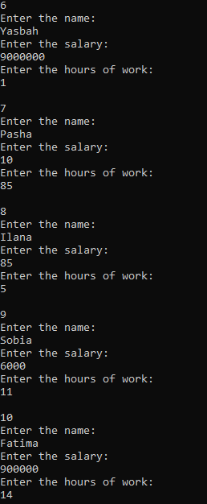

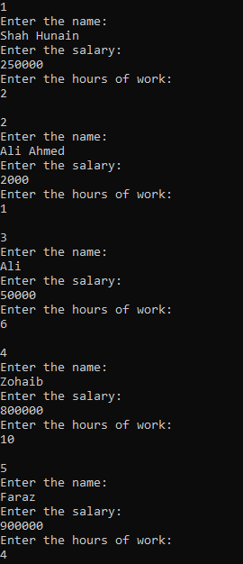

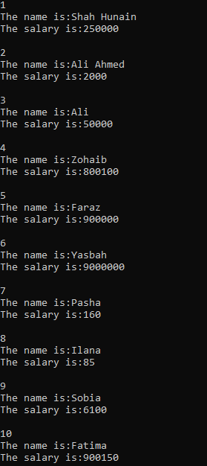

**QUESTION 05:**

**CODE**

#include<stdio.h>

#include<string.h>

struct Organization{

char organization_name[30];

char organization_number[30];

struct Employee{

int employee_id;

char employee_name[30];

int employee_salary;

}e1;

};

void main(void){

struct Organization o1;

printf("Enter the name of organization: ");

fflush(stdin);

gets(o1.organization_name);

printf("\nEnter the number of organization: ");

fflush(stdin);

gets(o1.organization_number);

printf("\nEnter the employee id: ");

scanf("%d",&o1.e1.employee_id);

printf("\nEnter the employee name: ");

fflush(stdin);

gets(o1.e1.employee_name);

printf("\nEnter the employee salary: ");

scanf("%d",&o1.e1.employee_salary);

//Printing the output

printf("\n\n");

printf("---------------------------------------------------\n");

printf("\nThe name of organization is: ");

puts(o1.organization_name);

printf("\nThe number of organization is: ");

puts(o1.organization_number);

printf("\nThe employee id is: ");

printf("%d",o1.e1.employee_id);

printf("\n\nThe employee name is: ");

puts(o1.e1.employee_name);

printf("\nThe employee salary is: ");

printf("%d\n",o1.e1.employee_salary);

}

**OUTPUT**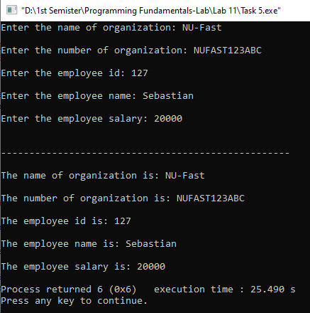

**QUESTION 06:**

**CODE**

#include<stdio.h>

struct date{

int dd;

int mm;

int yy;

};

void main(void){

struct date d;

printf("Enter the day-month-year: ");

scanf("%d %d %d", &d.dd, &d.mm, &d.yy);

d.dd=d.dd+45;

while(d.dd>31){

d.dd=d.dd-31;

d.mm=d.mm+1;

}

while(d.mm>12){

d.mm=d.mm-12;

d.yy=d.yy+1;

}

printf("\nThe updated date is: %d-%d-%d\n", d.dd, d.mm, d.yy);

}

**OUTPUT**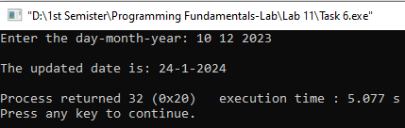

**QUESTION 07:**

**CODE**

#include<stdio.h>

#include<string.h>

struct Book{

int accession_number;

char author[30];

char title[30];

int is_issued;

};

void main(void){

struct Book library[100];

int n=0,i;

char choice;

while (choice!='7'){

printf("\t\t\tLibrary Menu:\n");

printf("1) Display all the books in the library\n");

printf("2) Add a book to the library\n");

printf("3) Display books by a particular author\n");

printf("4) Display the number of books by title\n");

printf("5) Display the total number of books present in the library\n");

printf("6) Issue a book from the library\n");

printf("7) Exit\n");

printf("Enter your choice: ");

fflush(stdin);

choice=getchar();

printf("\n");

switch(choice){

case '1': {

if (n==0){

printf("The books are not available in the library\n");

}

else{

printf("Books available in the library are:\n");

for (i=0; i<n; i++){

printf("Accession Number: %d\n",library[i].accession_number);

printf("Author: ");

puts(library[i].author);

printf("\nTitle: ");

puts(library[i].title);

printf("Issued: ");

if(library[i].is_issued==0){

printf("Yes\n");

}

else{

printf("No\n");

}

printf("----------------------------\n");

}

}

break;

}

case '2': {

if (n<100){

printf("Please enter the Accession Number: ");

scanf("%d",&library[n].accession_number);

printf("\nNow enter the Author's Name: ");

fflush(stdin);

gets(library[n].author);

printf("\nNow enter the Book Title: ");

fflush(stdin);

gets(library[n].title);

library[n].is_issued=0;

n=n+1;

printf("\nThe new book has been added successfully");

} else {

printf("\nA new book can not be added because the library is full");

}

break;

}

case '3': {

char author[30];

int count=0;

printf("Enter the name of author: ");

fflush(stdin);

gets(author);

for (i=0; i<n; i++) {

if (strcmp(library[i].author,author)==0){

printf("Accession Number: %d\n",library[i].accession_number);

printf("Author: %s\n",library[i].author);

printf("Title: %s\n",library[i].title);

printf("Issued: %s\n",library[i].is_issued ? "Yes" : "No");

printf("----------------------------\n");

count=1;

}

}

if (count==0) {

printf("No books found for ");

puts(author);

}

break;

}

case '4': {

char title[30];

int count=0;

printf("Enter book title: ");

fflush(stdin);

gets(title);

for (i=0; i<n; i++){

if (strcmp(library[i].title,title)==0) {

count++;

}

}

printf("Number of books with title %s: %d\n",title,count);

break;

}

case '5':

printf("\nThe total number of books in the library are: %d",n);

break;

case '6': {

int accession_number;

int count=0;

printf("Please enter the Accession Number of the book you want to issue: ");

scanf("%d",&accession_number);

for(i=0; i<n; i++) {

if (library[i].accession_number==accession_number) {

if (library[i].is_issued==0){

library[i].is_issued=1;

printf("Book with Accession Number %d issued successfully.\n",accession_number);

} else{

printf("Book with Accession Number %d is already issued.\n",accession_number);

}

count=1;

break;

}

}

if (count==0){

printf("Book with Accession Number %d not found.\n",accession_number);

}

break;

}

case '7':

printf("\nExit");

break;

default:{

printf("\nINVALID INPUT--");

printf("Please choose from the menu\n");

}

}

printf("\n\n");

}

}

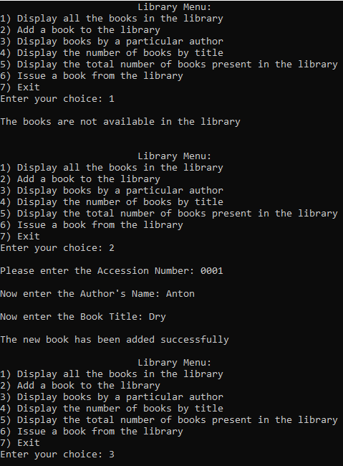**OUTPUT**

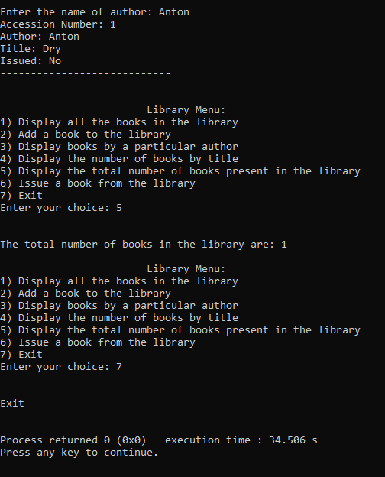

**QUESTION 08:**

**CODE**

#include<stdio.h>

int volume(int l, int w, int h);

void main(void){

int n,i;

printf("Please enter the number of boxes: ");

scanf("%d",&n);

for(i=0; i<n; i++){

int l, w, h;

printf("Enter dimensions of box %d (length-width-height): ",i+1);

scanf("%d %d %d",&l,&w,&h);

if (h<41){

int vol=volume(l,w,h);

printf("\nVolume of box %d is: %d\n",i+1,vol);

printf("The box can be transported\n\n");

} else{

printf("Box %d cannot be transported\n\n",i+1);

}

}

}

int volume(int l, int w, int h){

int answer=l*w*h;

return answer;

}

**OUTPUT**

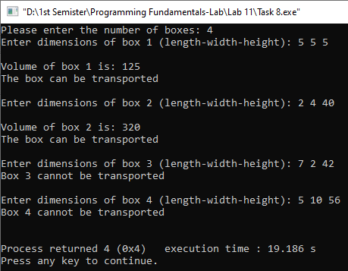

**QUESTION 09:**

**CODE**

#include<stdio.h>

#include<string.h>

struct Student{

int students_id;

char FirstName[20];

char LastName[20];

char cellno[12];

char email[30];

struct Register{

int CourseId;

char CourseName[20];

} r;

};

int main(void) {

struct Student std[5];

int i;

for (i=0; i<2; i++) {

printf("Enter the student id of %d student: ",i+1);

scanf("%d",&std[i].students_id);

printf("\nEnter the first name of %d student: ",i+1);

fflush(stdin);

gets(std[i].FirstName);

printf("\nEnter the last name of %d student: ",i+1);

fflush(stdin);

gets(std[i].LastName);

printf("\nEnter the cell number of %d student: ",i+1);

fflush(stdin);

gets(std[i].cellno);

printf("\nEnter the email of %d student: ",i+1);

fflush(stdin);

gets(std[i].email);

printf("\nEnter the course id of %d student: ",i+1);

scanf("%d",&std[i].r.CourseId);

printf("\nEnter the course name of %d student: ",i+1);

fflush(stdin);

gets(std[i].r.CourseName);

printf("\n");

}

printf("\n");

printf("-------------------------------------------");

for (i=0; i<2; i++){

printf("\nThe student id of %d student: ",i+1);

printf("%d",std[i].students_id);

printf("\n\nThe first name of %d student: ",i+1);

puts(std[i].FirstName);

printf("\nThe last name of %d student: ",i+1);

puts(std[i].LastName);

printf("\nThe cell number of %d student: ",i+1);

puts(std[i].cellno);

printf("\nThe email of %d student: ",i+1);

puts(std[i].email);

printf("\nThe course id of %d student: ",i+1);

printf("%d", std[i].r.CourseId);

printf("\n\nThe course name of %d student: ",i+1);

puts(std[i].r.CourseName);

}

}

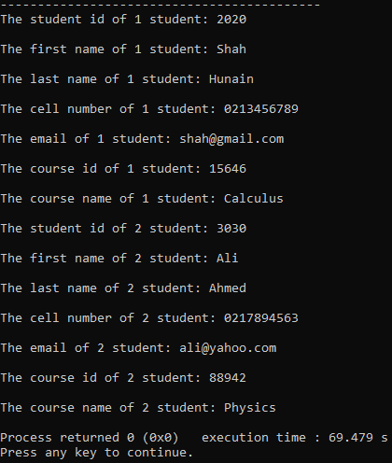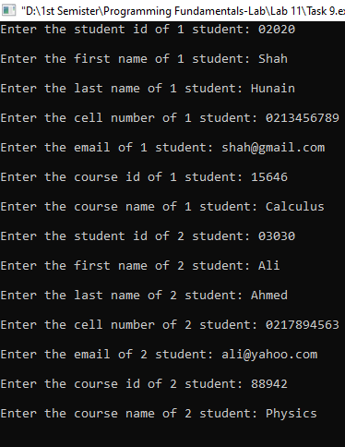**OUTPUT**